KONIC ELECTRONICS

Dear Koot van der Walt,

By this email we are formalizing the welcome of the company KONIC ELECTRONICS as partner company of FCI.

We are looking for a long, positive and mutually beneficial association.

Please send us as soon as possible your company logo and contacts to insert in the FCI site in the special section that is going to be created for the Partner Companies.

You are also given the permission to insert the statute and the logo of FCI on your site and products (attached the FCI logo)

As a start we are informing that the company KONIC ELECTRONICS, having become a Partner Company of the FCI, will have right to a 5% discount on the stand fee on the next Olympiad in Dortmund in February 2026.

Best Regards

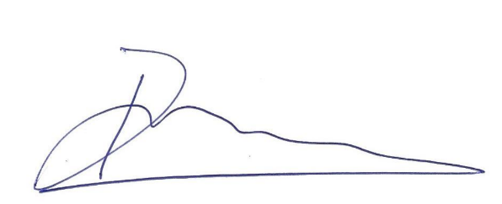
Dr. David Barros MADEIRA
FCI President


